Task 3

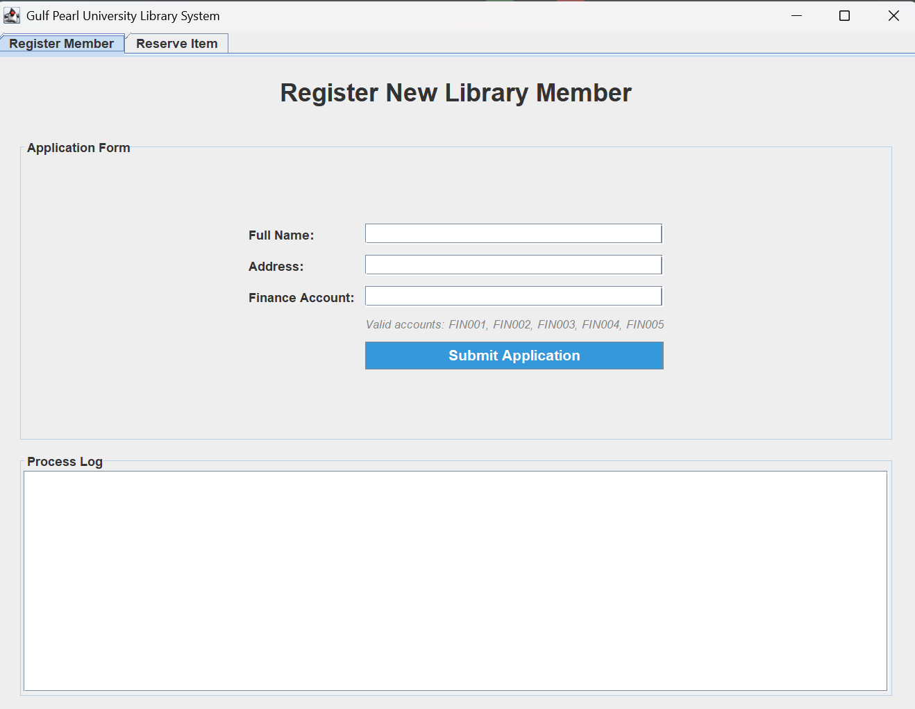

The use case starts when the user selects Register Member from the main menu of the library system. The system displays the registration form for a new library member. The user is presented with empty input fields to enter the full name, address, and finance account number. Valid finance account options are shown to guide correct input.

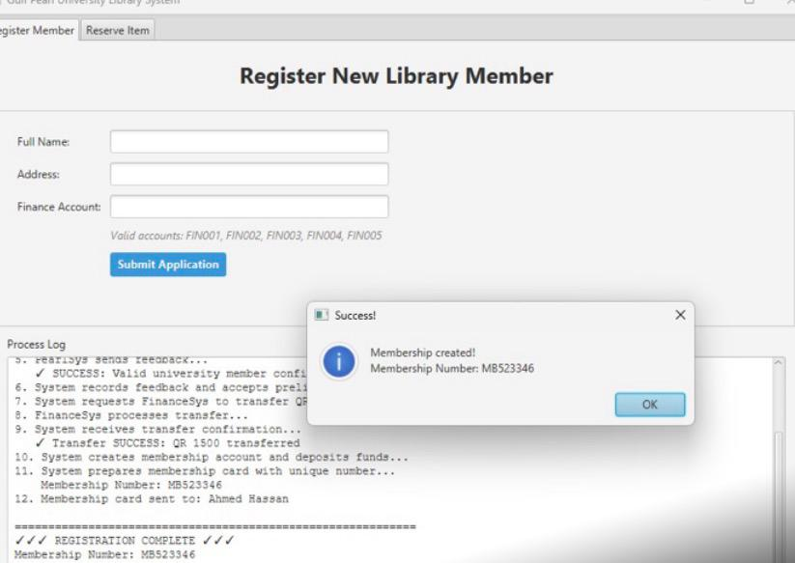

The user is prompted to enter the full name, address, and finance account number of the applicant. The system provides a list of valid finance account IDs to guide the user. After the user fills in all required information, the Submit Application button is pressed. The system validates the entered data before processing the registration. This confirms that the application has been processed correctly. After successful validation, the system registers the new library member. Confirmation messages are displayed in the Process Log section.

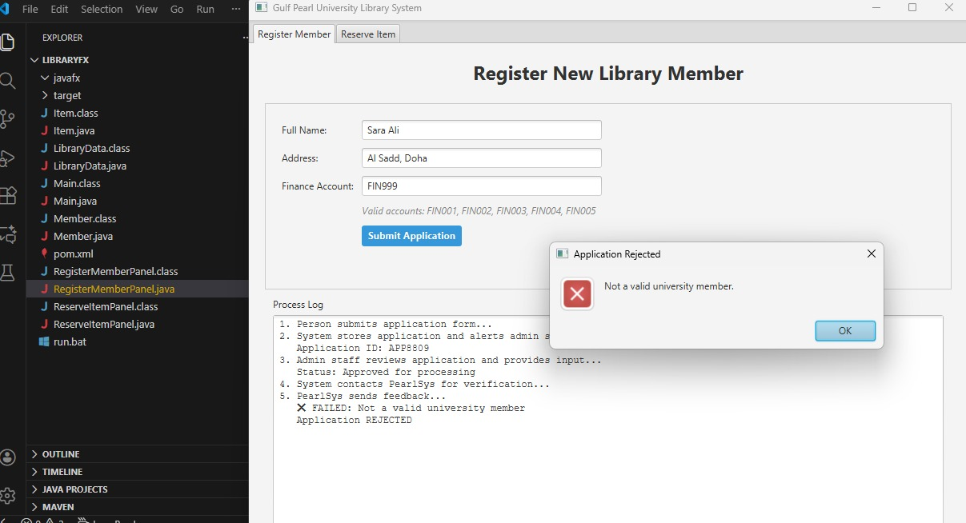

The system validates the entered information, including the finance account number. Any errors or system messages are displayed to the user.

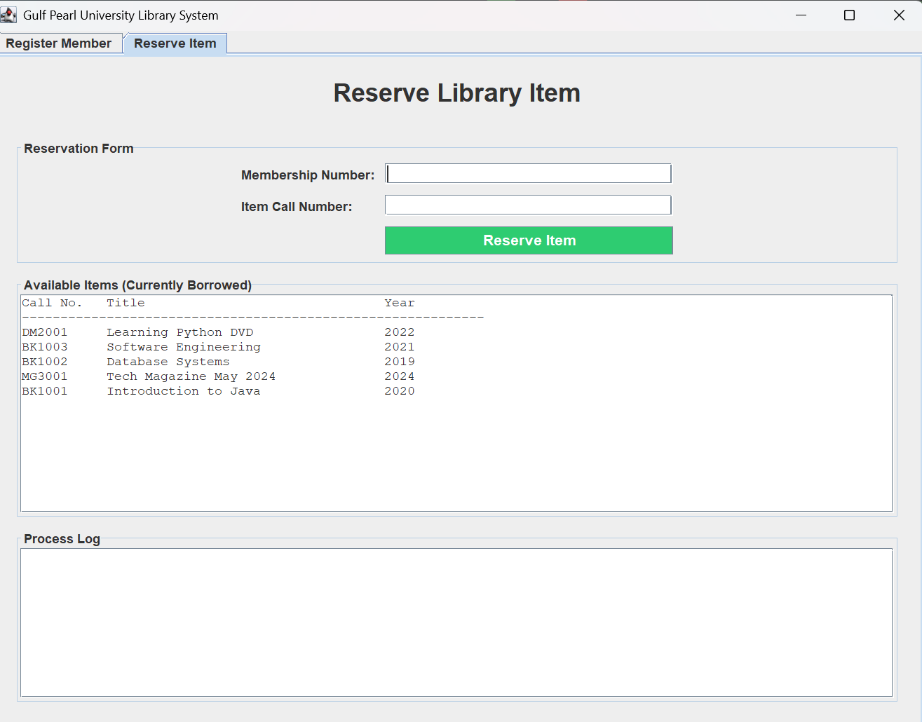

The user selects the Reserve Item option from the menu. The system displays the reservation interface.

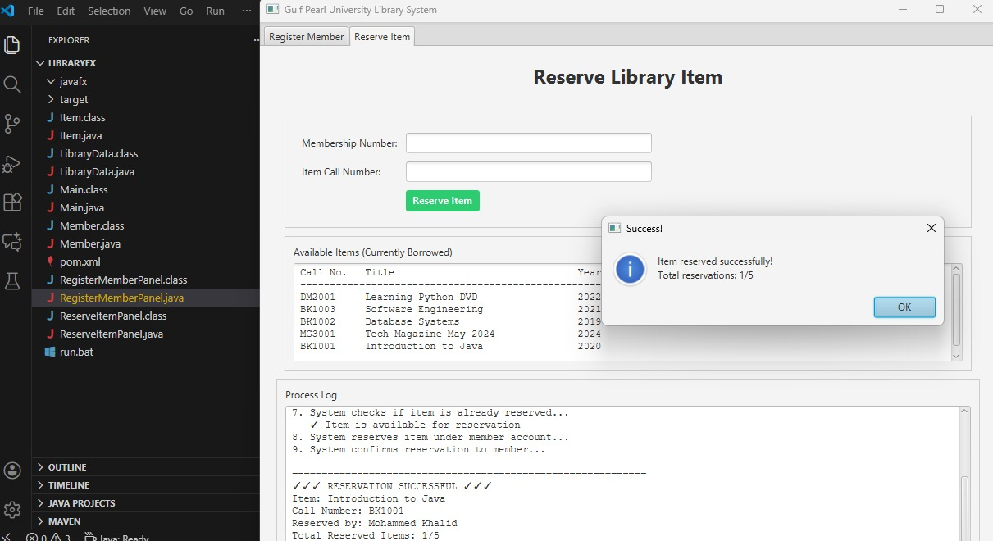

The user enters the item and member details required for reservation. The system verifies item availability. Once validated, the system confirms that the item has been successfully reserved. A confirmation message appears in the process log.

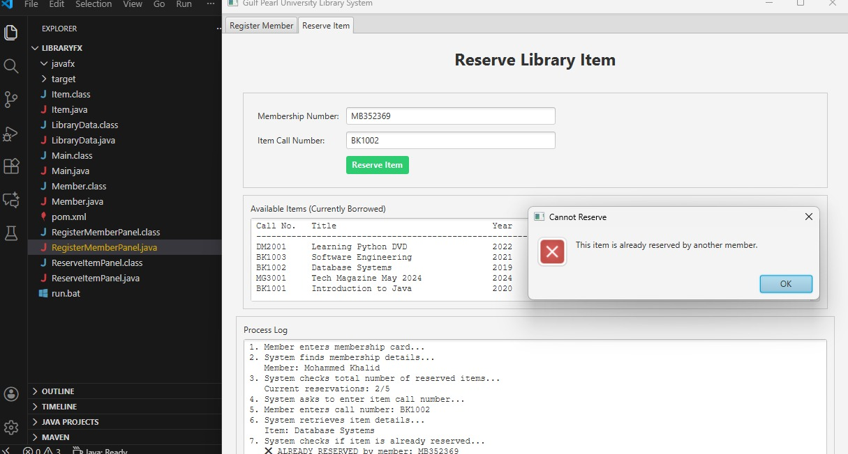
The system checks the item’s status and determines that it is already reserved by another member, so the reservation is rejected. An error message is displayed to inform the user.

In our implementation, since we don't have an actual PearlSys or FinanceSys API to integrate with, we assumed that the university verifies students using the Finance Account ID. If the Finance ID exists in our predefined university member list, then we consider the applicant an approved student.
The same Finance Account is also used to simulate the deposit transfer of QR 1500.
So one successful check represents:
-University membership validation
-Finance transfer approval
This allowed us to satisfy the use case flow while keeping the implementation realistic and testable.

